|  |  |
| --- | --- |
|  | FIRA Challenge - Autonomous Cars  Laws of the Game (Youth) |

Amirmohammad Zarif, Amirmahdi Zarif and Soroush Sadeghnejad

1 Bio-Inspired System Design Laboratory, Biomedical Engineering Department, Amirkabir University of Technology Tehran, 158754413, Iran

[s.sadeghnejad@aut.ac.ir](mailto:s.sadeghnejad@aut.ac.ir)

***Abstract***

The focus of the FIRA Autonomous Cars competition is encouraging researchers to develop self-driving cars. In FIRA Autonomous Cars, two environments are designed for cars to compete against each other. The first environment is a racing circuit and the second one is an urban environment. Each environment has its own score and the total score of competitors will be the sum of both scores.

**[FAC-1] Rules of the Game**

The RC Car (from now on inside this document will be called car) used for this competition should be electrically powered. Fuel-based cars cannot participate in this competition. Please remember that your car has to abide by the following limits to be able to participate in the competition:

* Length: 350mm - 550mm
* Width: 150mm - 350mm
* Height: 450mm
* Electrically powered

Keep in mind that the car should have the Ackerman steering system.

Both 4WD and 2WD cars are allowed for the competition and cars will be quarantine minutes before each group run. Cars used for this competition should have 4 wheels and Ackermann steering mechanism. The picture below shows an example of acceptable cars with the Ackerman steering mechanism.

**Please consider that infrared line follower sensors are not allowed.** For general specifications relevant to all FIRA events (e.g., playing field, lighting, and responsibility of the referees) please refer to General - FIRA Laws of the Game.

It is also important to note that each team can only use one car or platform, and although it’s illegal to change the platform it is permissible to modify the car components for repair.

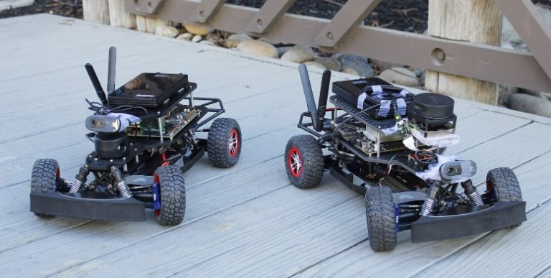

**[FAC-2]: Game Structure**

There are two stages in the competition, preliminary and final. Depending on an achieved score in the preliminary stage, some teams will be qualified for the final stage. Achieved scores during the preliminary stage will be reset to zero for the final stage. The order of participation in a stage is decided by a draw, a day before the start of the competition. Teams that are not present during the draw, will start the stage first, using another draw by present teams.

This competition consisted of two parts, each part has its own scoring model and the total score will be the sum of the scores each team has obtained in both parts. The first part is called “Autonomous Race” and in this part, each car has to complete a race track autonomously one or more times depending on the stage. The second part is called “Autonomous Urban Driving” and in this part, each car should complete the specified task such as navigation according to road signs. Both parts are introduced in more detail in the next sections of this document.

# [FAC-3]: Autonomous Race

In the race part of the competition, each car has to do some laps of a race track completely autonomous. Multiple checkpoints are inside the track and cars have to cross them while navigating through the track. Each missed checkpoint will result in a penalty. Depending on the stage, some obstacles might be placed inside the track and cars have to avoid them.

در بخش مسابقه مسابقه، هر ماشین باید چند دور از یک مسیر مسابقه را کاملا مستقل انجام دهد. چندین ایست بازرسی در داخل مسیر قرار دارند و خودروها باید هنگام حرکت در مسیر از آنها عبور کنند. هر نقطه بازرسی از دست رفته منجر به جریمه خواهد شد. بسته به مرحله، ممکن است برخی از موانع در داخل پیست قرار گیرند و اتومبیل ها باید از آنها اجتناب کنند.

During this part of the competition, each team has a specific amount of time and during this time they have 5 runs. The maximum score of each run will be considered as the score of this part. The track will have a width of 50cm ± 10% for this section. **There is at least one turn with an outer turning radius of 1.5m ± 10% , your car should be able to turn in such conditions.**

The image below shows an example of a race track :

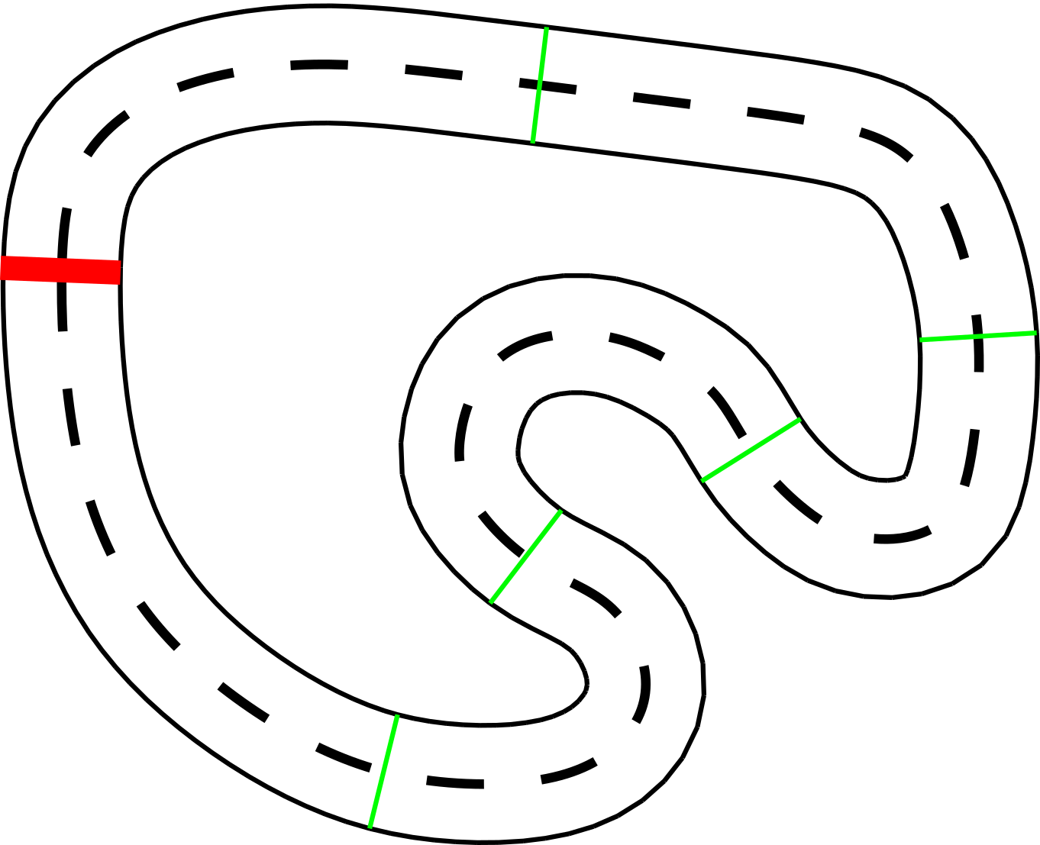

As shown in the image, the **track will be drawn on the ground using two white or black continuous sidelines and one dashed lane marking of the same color marking the middle of the track.** The color of markings will be selected according to the color of the arena floor thus teams should be able to work with both colors. The checkpoints are shown in green and the start/finish line is shown in red. Checkpoints do not necessarily have any marking and the picture is just for demonstration. The start/finish line will be marked using a different color than road markings but not necessarily red.

همانطور که در تصویر نشان داده شده است، مسیر بر روی زمین با استفاده از دو خط کناری پیوسته سفید یا سیاه و یک خط نقطه چین با همان رنگ که وسط مسیر را مشخص می کند، ترسیم می شود. رنگ علامت گذاری ها با توجه به رنگ کف سالن انتخاب می شود، بنابراین تیم ها باید بتوانند با هر دو رنگ کار کنند. نقاط بازرسی با رنگ سبز و خط شروع/پایان با رنگ قرمز نشان داده شده است. ایست های بازرسی لزوماً هیچ علامتی ندارند و تصویر فقط برای نمایش است. خط شروع/پایان با استفاده از رنگی متفاوت از خط کشی جاده اما نه لزوماً قرمز مشخص خواهد شد.

The markings width is at least 1cm and two dashed lines have a minimum space of 5cm between them. Depending on the stage, there might be some obstacles inside the track and cars have to avoid them. If cars hit any obstacle inside or outside the track, their current run will be considered as finished.

عرض علامت ها حداقل 1 سانتی متر است و دو خط چین حداقل 5 سانتی متر فاصله بین آنها دارند. بسته به مرحله، ممکن است برخی از موانع در داخل پیست وجود داشته باشد و اتومبیل ها باید از آنها اجتناب کنند. اگر اتومبیل ها به مانعی در داخل یا خارج از پیست برخورد کنند، اجرای فعلی آنها به عنوان پایان یافته در نظر گرفته می شود.

# [FAC-4]: Autonomous Urban Driving

For this part of the competition, cars have to navigate autonomously through an urban environment. Cars will start from a starting point and have to navigate through streets using street signs, lane markings, zebra crossing,tri and other information available to be used by vision sensors. There are checkpoints inside the streets and each checkpoint has specific points. Every incorrect decision made by the car will result in a penalty which is discussed in detail in the score section.

برای این بخش از رقابت، خودروها باید به طور مستقل در محیط شهری حرکت کنند. خودروها از نقطه شروع شروع می شوند و باید با استفاده از علائم خیابان، خط کشی، تقاطع گورخر، tri و سایر اطلاعات موجود برای استفاده توسط حسگرهای بینایی در خیابان ها حرکت کنند. در داخل خیابان ها ایست بازرسی وجود دارد و هر پاسگاه دارای نقاط خاصی است. هر تصمیم نادرستی که توسط ماشین گرفته شود منجر به جریمه می شود که در قسمت امتیازات به تفصیل مورد بحث قرار گرفته است.

During this part of the competition, each team has a specific amount of time and during this time they have 3 runs. The maximum score of each run will be considered as the score of this part. The track width is 60cm ± 10% for this section.

در این بخش از مسابقات، هر تیم زمان مشخصی دارد و در این مدت 3 دوش دارد. حداکثر امتیاز هر اجرا به عنوان امتیاز این قسمت در نظر گرفته خواهد شد. عرض مسیر برای این بخش 10 ± 60 سانتی متر است.

A marker will be placed below each street sign which makes it easier to recognize the sign using vision sensors. Markers will be April Tags (36h11 family) with a size between 4cm x 4cm and 8cm x 8cm. The urban arena will look like the picture below (this is not the street map and is just for demonstration purposes):

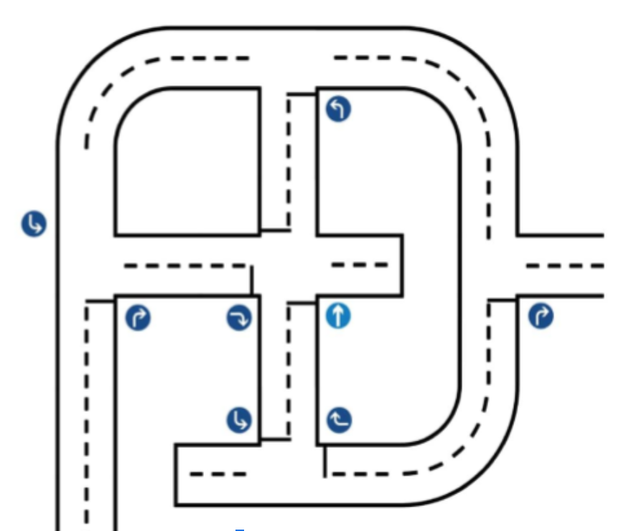

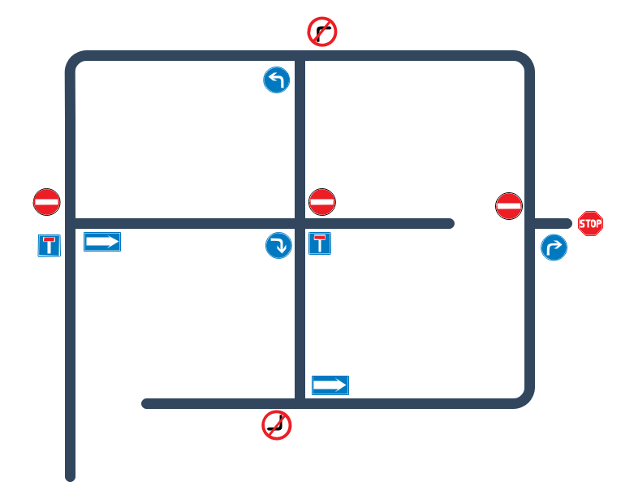

In the picture above, cars have to start from the bottom right and follow the street based on the street signs, reach the destination and stop where the stop sign is. There is at least one checkpoint between every two junctions. Every incorrect turn has a specific penalty and also the car has to move along the correct lane. Each street has one of the markings shown in the picture below:



The marking indicates a one-way street. Therefore the car can change lanes

List of street signs is as below :

|  |  |  |  |
| --- | --- | --- | --- |
| Sign Name | Sign Picture | Sign Marker | Car Decision |
| ٔNo Entry |  |  | Should not enter the street which has this sign in the beginning of it. |
| Dead End |  |  | Should not enter the street which has this sign in the beginning of it. |
| Proceed Right |  |  | Should choose the road on the right of the junction. |
| Proceed Left |  |  | Should choose the road on the left of the junction. |
| Proceed Forward |  |  | Should proceed forward. |
| Stop |  |  | Should stop (this is the destination). |

Cars also have to stop for at least 3 seconds before the zero crossings of each junction. Some penalty points will be considered if the car crosses the junction without any stop. The same rules of the previous part apply to width and type of road markings in this section.

**Note: There will be no obstacles in the road for the youth category.**

There is a stop line about one centimeter before the zebra crossings of each junction that is vertically located by zebra crossings and cars should stop before this line.

همچنین خودروها باید حداقل 3 ثانیه قبل از عبور از صفر هر تقاطع توقف کنند. اگر خودرو بدون توقف از تقاطع عبور کند، برخی از امتیازات جریمه در نظر گرفته می شود. همان قوانین قسمت قبل در مورد عرض و نوع خط کشی های جاده در این قسمت اعمال می شود.

توجه: برای رده جوانان هیچ مانعی در راه وجود نخواهد داشت.

حدود یک سانتی متر قبل از گذرگاه های گورخری هر تقاطع یک خط توقف وجود دارد که به صورت عمودی توسط گذرگاه های گورخری قرار دارد و خودروها باید قبل از این خط توقف کنند.



# [FAC-5]: Score Calculation

Each part of the competition has its own scoring model, scoring models are listed below.

### **[FAC-5-1]: Level of Autonomy**

Cars have to do the missions completely autonomously. This can be done by using a computer onboard or offboard. A coefficient will be multiplied in the final score of teams based on their level of autonomy. This coefficient is defined as below :

|  |  |
| --- | --- |
| **Level of Autonomy** | **Ka (coefficient)** |
| Offboard | 0.5 |
| Onboard | 1 |

Each team has the choice of using the signs or the April Tags, but the scores are calculated according to the following table:

|  |  |
| --- | --- |
| **Level of Autonomy** | **Ka (coefficient)** |
| April Tags | 1 |
| Signs | 1.3 |

### 

### **[FAC-5-2]: Autonomous Race Scoring Model**

During the race part, a score will be calculated based on the total time. Total time is the sum of the time taken for the car to complete the track or pass some checkpoints and other penalties that will be added to total time depending on how well the car has followed the track autonomously. The penalties table is shown below:

|  |  |
| --- | --- |
| **Penalty Definition** | **Penalty Time** |
| Skipped checkpoint (each) | + (s) |
| Parts fell (each) | + (s) |

A score of this part is calculated using the following formula :

𝑆𝐴𝑅 = (1 + max{ , 0}) * 35 * cp

The stage time (Tstage) is the amount of time each team has to do the race in each stage which will vary between preliminary and final stage. For example, if a team is given 200 seconds and can finish the competition in 100 seconds and not lose any checkpoints (for example, if it scores 14 checkpoints), it will receive 735 points.

### **[FAC-5-3]: Autonomous Urban Driving Scoring Model (After 2022)**

In this part, cars have to start from a starting point and navigate in the streets according to the signs and reach the destination point. Each checkpoint reached by car has 60 points. The sum of these points minus the sum of the penalty points each car received during its navigation will be the score of this part. The penalty points table is shown below :

|  |  |
| --- | --- |
| **Penalty Definition** | **Penalty Points** |
| No stop injunction | -10 |
| The incorrect decision injunction | -30 |

### **[FAC-5-4]: Total Score**

The total score is sum of the autonomous racing and autonomous urban driving scores:

Notes :

* The finish line is considered a checkpoint.
* **The car should not necessary be in the right lane, and eaitherway, passing a checkpoint from right lane or left lane would be considered as a checkpoint for the youth category.**
* The scores of each part can not become negative.
* If the car gets out of the road in an urban environment, it will be considered as a collision with the road barrier and run will be finished.
* The team leader can say “STOP” during the race at any time and the run will be considered as finished.
* Touching or manipulating the car without saying “STOP” will reset the run and no score would be calculated for that run.

These notes apply to both autonomous racing and autonomous urban driving.

# [FAC-6]: Technical Document and Video

Each team has to send a technical document as well as a Video from their car. You can find the technical document template inside the FIRA website. The technical document should contain information about both hardware and software used in the car.

# [FAC-7]: Rules Change

These rules may be changed by the technical committee at any time before the competition. Teams have to check these rules regularly to make sure they know about any changes made. The latest version of official FIRA Autonomous Cars rules is always available using [this](https://docs.google.com/document/d/1pyhgvSQw7eaGDG0dzchA0VkbOYnGsd1_AVNhvs1iz8c/edit) link.

Last edit date: March 2, 2023 (v1.1.4)